|  |  |  |  |
| --- | --- | --- | --- |
| \\lyng-dc1\StaffShared\Learning Bugs Animals ALL subjects\characters bugs animals\Cyril the Snail - History.jpeg**Lyng Primary School Knowledge Organiser** | | | |
| **History Topic: Titanic** | **What happened to the Titanic?** | Year 1 | Spring 1 |

|  |  |
| --- | --- |
| **What Step On and Goldilocks words will I use?** | |
| **Spelling** | **Definition** |
| iceberg | A large floating mass of ice that has broken from a glacier. |
| glacier | A large mass of ice formed in cold regions from compacted snow and very slowly moving down a slope or across land. |
| survivor | A person who survives. |
| unsinkable | Unable to sink |
| lifebelt | A life saver that fastens around a person's waist like a belt. |
| lifeboat | a boat made for quick rescue of people. It can be carried on a larger boat, or it can be used from shore. |
| passengers | a person who is not driving, but travels in an automobile, bus, train, or other vehicle. |
| collision | an act or instance of coming together with force; crash. |
|  |  |
|  |  |
|  |  |
|  |  |

**Background information for parents and teachers**

RMS Titanic was a British passenger and mail carrying ocean liner, operated by the White Star Line. It sank in the North Atlantic Ocean on 15 April 1912 as a result of striking an iceberg. The journey was from Southampton, England, to New York City, United States.

Of the estimated 2,224 passengers and crew aboard, about 1,500 died, making it the deadliest sinking of a single ship up to that time. The disaster drew public attention, spurred major changes in maritime safety regulations, and inspired many artistic works.

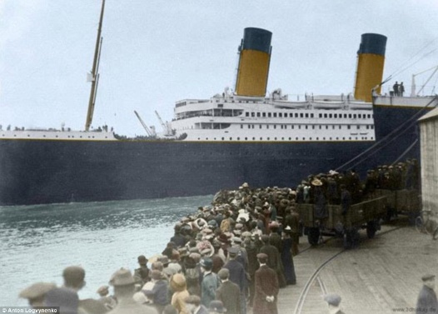

|  |
| --- |
| **When? (Timeline of key events)** |

1. **April 10, 1912**: The Titanic departed from Southampton, England, on its maiden voyage to New York City, USA. It made stops in Cherbourg, France, and Queenstown (now Cobh), Ireland, before heading across the Atlantic Ocean.
2. **April 14, 1912**: The Titanic struck an iceberg at around 11:40 PM (ship's time) while sailing in the North Atlantic Ocean. The iceberg caused extensive damage to the ship's hull, leading to flooding in several compartments.
3. **April 15, 1912**: At around 2:20 AM, the Titanic sank beneath the icy waters of the Atlantic Ocean. The ship broke apart as it went down, with the bow sinking first followed by the stern.
4. **Rescue and aftermath**: The nearby RMS Carpathia received distress signals from the Titanic and rushed to the scene to rescue survivors. However, more than 1,500 passengers and crew perished in the disaster, making it one of the deadliest maritime tragedies in history.

**Hook** 

Make a ship in the hall, design a ticket and go on-board the ship.

**Great Quotes**

**TRIP/VISITOR**

Immersive room

"There is no danger that Titanic will sink. The boat is unsinkable and nothing but inconvenience will be suffered by the passengers."

-Phillip Franklin, White Star Line Vice-President

**Our Storytelling Approach to enhance engagement**

|  |  |  |
| --- | --- | --- |
| **People:**  Eva Hart | **Place:**  Titanic ship | **Problem:**  It has sunk. Will Eva Hart survive? |

**Key People**

**Agreed Outcome**

Write a newspaper article.

**Eva Hart** - “I saw that ship sink … I saw it, I heard it, and nobody could possibly forget it.” She remembered the stars shining overhead and the terrible stillness of the scene broken up by the screams of survivors.

**John Jacob Astor IV** - Famous for marrying is his wife Madeleine on September 11th 1911, who at the time was only 18 years old. Also he was the richest man aboard the ship, when his body was recovered he had $2440 on him.

**Captain Edward John Smith** - Famous for being nicknamed the millionaires captain, it became a custom for the company to appoint him to the command of each of their finest ships as it came into operation.

**Thomas Andrews** - Famous for being the designer of Titanic and he was last seen by a steward looking at a painting of Plymouth.



**Key questions**

* When was the Titanic built?
* How did the Titanic sink?
* Who was Eva Hart and why is she famous?
* How do people know about the Titanic sinking?

|  |  |  |  |
| --- | --- | --- | --- |
| \\lyng-dc1\StaffShared\Learning Bugs Animals ALL subjects\characters bugs animals\Cyril the Snail - History.jpeg**Lyng Primary School Knowledge Quiz** | | | |
| **History Topic: Great and Ghastly Events** | **Titanic** | Year 1 | Spring 1 |

|  |  |  |
| --- | --- | --- |
| 5. Where was the Titanic going? | **S** | **E** |
| Southampton |  |  |
| North Pole |  |  |
| New York |  |  |

|  |  |  |
| --- | --- | --- |
| 1. Where did Titanic sink? | **S** | **E** |
| Indian ocean |  |  |
| Atlantic ocean |  |  |
| Pacific ocean |  |  |

**Our Titanic Quick Quiz**

|  |  |  |
| --- | --- | --- |
| 1. How many people died on the Titanic? | **S** | **E** |
| 5 |  |  |
| 1600 |  |  |
| 1500 |  |  |

|  |  |  |
| --- | --- | --- |
| 1. Did Eva Hart survive? | **S** | **E** |
| Yes |  |  |
| No |  |  |

|  |  |  |
| --- | --- | --- |
| 1. What did the Titanic hit into? | **S** | **E** |
| castle |  |  |
| iceberg |  |  |
| Another ship |  |  |